Email / Mobile no. Update : INDIVIDUAL
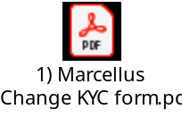 To be signed by both account holders
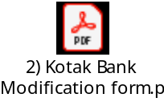

To be signed by the account holder requesting the change.
 To be signed by the account holder requesting the change .
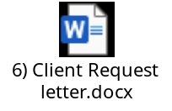 To be signed by the account holder requesting the change.
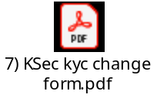 Required for NRI clients of Kotak Custody, to be signed by the 1st account holder, as Trading account in in the name of the 1st holder.

Type of Modification | Documentation Required: Individual
Email id / Mobile number | NA

