Address Update : INDIVIDUAL
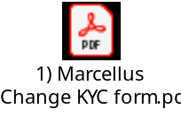 Required by Marcellus for updating in Client PMS records.
To be signed by both holders

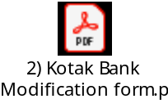
Required to update details at CRN level.
To be signed by the holder whose details are getting changed.

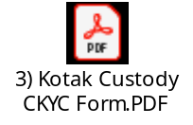 To be signed by the account holder whose address is being modified/changed

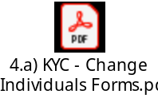 To be signed by the account holder whose address is being modified/changed

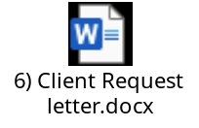 Required only if account has more than 1 account holder

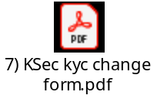 Required for NRI clients of Kotak Custody , to be signed by the 1st account holder, as Trading account in in the name of the 1st holder.
Type of Modification | Documentation Required: Individual
Address update | 1) Self attested Pan copy with IPV/OSV done  2) Self attested OVD copy  (Adhaar Card, Voter ID , Passport, Driving license) IPV/ OSV done.  * CKYC form should also be have IPV / OSV stamp & sign

